Charity Day
Pat Thornley Celebration Trophy
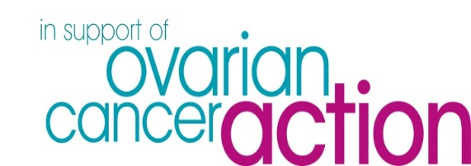

Friday 4th October 2024 – First tee 07:48
Closing date for entries: Friday 20th September 2024
FORMAT
18 Hole 4 Ball AM-AM – Played off 85% Handicap (No Handicap Limit)
Open to Members and Non-members - Ladies and Men
2 scores to count on all holes apart from 9 and 18 where all 4 scores count

PRIZES
1st, 2nd and 3rd placed teams
Ladies: nearest the pin in two on the 6th, nearest the pin on the 16th
Men: nearest the pin on the 5th, nearest the pin in two on the 18th
COST £180 per team of 4
Includes entry fee, green fee, half-way house, meal and donation to charities
Refreshments available to purchase on arrival from the Clubhouse

How to pay: BACS or by cheque payable to Lakeside Lodge Golf Club*
BACS - Account name: Lakeside Lodge Golf Club
Sort code: 20-43-63 Account no: 10557188
Reference: “Your surname - Pat Thornley”
Cheque - *Post to - c/o Tracy Bass, Lakeside Lodge Golf & Country Club, Fen Road, Pidley, Huntingdon PE28 3DF

The Trophy and other prizes will be presented once all players have completed their round and the cards have been checked.
Entry Form
Please fill in the entry form below stating if you require meat or vegetarian meal option and indicate any dietary requirements.

 | Name | My EG Membership Number | Veg / Meat  Lasagne | Dietary requirements
Player 1
Player 2
Player 3
Player 4
Contact Email Address

Payment Options: BAC or Cheque | Please tick
BACs:
Account name: Lakeside Lodge Golf Club
Sort code: 20-43-63 Account no: 10557188
Reference: “Your surname - Pat Thornley
Cheque payable to: Lakeside Lodge Golf Club

Please take envelope to Lakeside Lodge Office addressed to Tracy Bass

